Serial No:
Sessional I
Total Time: 60 minutes
Total Marks: 40
________________
Signature of Invigilator

CS301-Theory of Automata

Tuesday, Sept 15, 2015
Course Instructor
Dr. Aftab Maroof, Ms. Mehreen Alam

_____________________________________________ _____________________
Student Name Roll No Section Signature

DO NOT OPEN THE QUESTION BOOK OR START UNTIL INSTRUCTED.
Instructions:
- Understanding the question paper is also part of the exam, so do not ask any clarification.
- The question paper is printed on both sides of the pages.
- Attempt all questions on the same sheets/pages and within the space provided with each question. You may lose marks if you write in extra space.
- Make sure that this question paper contains seven (07) pages including title page. Be brief, smart and efficient!
- Use permanent ink pens only. Any part done using soft pencil will not be marked and cannot be claimed for rechecking.

Question | 1 | 2 | 3 | 4 | 5 | 6 | Total
Marks Obtained
Total  Marks | 5 | 5 | 5 | 5 | 5 | 15 | 40

Vetted By: _____________________________Vetter Signature: _____________________

Q1. [5 pts]Give recursive definition for the set POWERS-OF-THREE = {1, 3, 9, 27, 81,..}

Q2. [5 pts]Write regular expression for the language over the alphabet {a,b} that all words begin with zero or more b’s followed by any odd clumps of a’s and odd number of b’s.

Q3. [5 pts]Give the state diagram of an FA for the following language 10+(0+11)0*1 over the alphabet {0,1}

Q4. [5 pts]Convert the following TG to an RE using the algorithm studied. For full credit, show all the steps clearly. ∑ = {0,1,2}
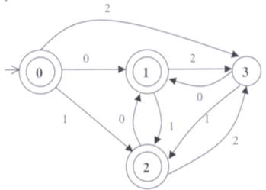

Q5. [5 pts]Give state diagram of an NFA recognizing the language represented by the regular expression a+( a*b + ab )* over the alphabet {a,b}.

Q6. [7+5+3] = 10pts]Consider the following NFA. Use the algorithms studied and show all steps to get full credit.
- Convert this NFA to the corresponding DFA. Show the resultant transition table and the state diagram.
- Minimize this DFA. Show the resultant state diagram.
- Convert the minimized DFA in to RE.
